1 Write the stages of development of a star in the correct order. The star is larger than the Sun.
A Protostar
B Supernova
C Main sequence star
D Red giant
E Dust and gas
F Neutron star or black hole (6)
2 a) What force acts on dust and gas in space? (1)

b) What is the name of the process which releases energy in the core of the Sun? (1)

c) Why doesn’t the Sun collapse due to the pull of gravity on it? (2)

d) Jupiter and Saturn are giant planets. They are made mostly out of hydrogen. Why don’t they produce their own light as the Sun does? (2)

3 Explain the nature of each of these types of objects.
a) Main sequence star

b) Supernova

c) White dwarf

d) Black hole (8)

4 Name the four inner planets in order of distance from the Sun. Put the nearest first. (2)

5 Explain the difference between a moon and a dwarf planet. (2)

6 Fill in the gaps with the correct words from the list below.
fission fusion hydrogen lithium helium carbon
The Sun’s energy is derived from nuclear ………………………. in which atoms of …………………. fuse to form ………………………….. . (3)
7 Explain why a body such as a planet, moving in a circular orbit around the Sun, can have a constant speed but a changing velocity. (2)

8 What does the Big Bang Theory suggest about the origin of the universe? (2)

9 Light reaching planet Earth from distant galaxies is shifted toward the red end of the spectrum. Explain why. (3)

10 The diagram shows a satellite, S, travelling around the earth.
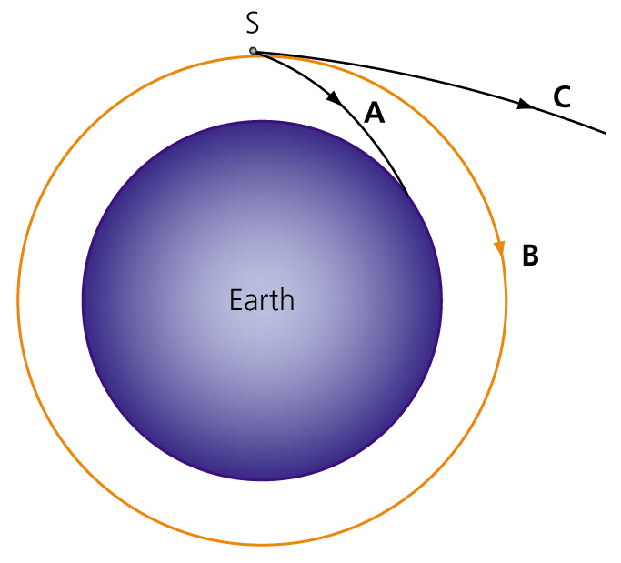
Answer the following questions.
a) If its velocity is too great does the satellite follow path A, B or C? (1)

b) What happens to the satellite? (1)

c) If the velocity is too low to maintain a stable orbit does the satellite follow path A, B or C? (1)

d) What happens to the satellite on this path? (1)

e) Complete the equations to calculate the speed of a satellite in a circular orbit about a planet.
Distance = 2 × …….. × orbital ………………..
time (2)
f) Calculate the orbital speed of Venus. Venus is 108 million km from the sun and takes 225 days to complete its orbit.
Give your answer in km/h. (2)

11 The diagram shows the path of a comet orbiting the Sun. A comet is a large lump of rock and ice.
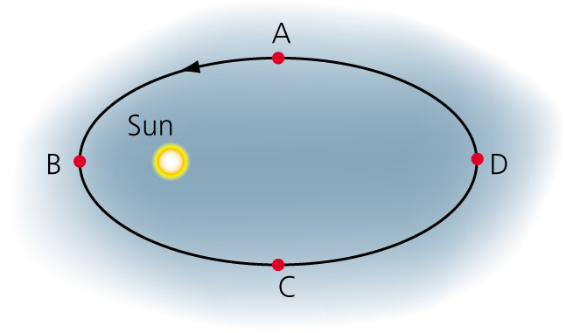
a) At what point in the orbit, A, B, C or D, will the comet be travelling:
i) the fastest? (1)

ii) the slowest? (1)

b) What causes the comet to change speed during its orbit? (1)

c) Is gravity a contact or a non-contact force? (1)

TOTAL = 46

1 E, A, C, D, B, F (6)
2 a) Gravity (1)
b) Nuclear fusion (1)
c) The outward pressure from the nuclear reactions balances the inward pressure of gravity. (2)
d) Jupiter and Saturn are not big enough to create enough pressure at their cores to fuse hydrogen into helium. They cannot start the nuclear fusion process which happens in the Sun. (2)
3 a) A main sequence star is one that is stable. It releases energy by fusing hydrogen to
form helium. (2)
b) A supernova is a gigantic explosion caused by uncontrolled fusion reactions in very
large star. (2)
c) A white dwarf is a very small hot object that forms when some stars collapse after they
have run out of hydrogen. (2)
d) A black hole is an immensely dense object from which nothing (including light) can escape. (2)
4 Mercury, Venus, Earth, Mars (2)
5 A moon is an object orbiting a planet. A dwarf planet is an object that orbits the Sun. (2)
6 The Sun’s energy is derived from nuclear fusion in which atoms of hydrogen fuse to form helium. (3)
7 Velocity is a vector quantity that has speed and direction. As a body orbits the Sun, its
direction is constantly changing. Therefore its velocity is constantly changing even if its speed is the same. (2)
8 This theory suggests that the Universe began about 13.8 billion years ago when all matter and space was created and expanded violently from a single point. (2)
9 Distant galaxies are moving away from Earth. When a source of light is moving away from
us, the wavelength of the light that we see becomes longer. So the light moves towards the red end of the spectrum. We say that the light has been red-shifted. (3)
10 a) C (1)
b) It shoots off into space. (1)
c) A (1)
d) It burns up in the atmosphere/crashes into the earth. (1)
e) Distance = 2 × π × orbital radius
time (2)
f) = 3.01 × 10⁶ km/day = 1.256 × 10⁵ km/h (2)

11 a) i) A (1)
ii) D (1)
b) The gravitational pull of the Sun. (1)
c) Non-contact (1)
TOTAL = 46

